Note: This tool can be used only if you are trying to create multi database with more than one territory. Following are the list of steps that needs to be followed to create multiDB.

1. Place each territory related XML file in sequential folder names A, B, C, D etc. Here Folder name A indicates that this is the first territory. B is second territory. C is third territory and so on.
2. Generate binaries for each territory in corresponding folders.
3. Run vbs script file in each territory folder.
4. Double click application “GenarateMultiDB.exe”.
5. Click on button “Click here to select multiDB path” and select the folder where individual territories are placed (A, B, C, D, etc…) like shown in below image.

**Note: Make sure selected path doesn’t have folders “Temp” and “MiltiDB_output”. If it is there please delete those folders. Final result with multiple databases will be written to “MiltiDB_output” fodler.**

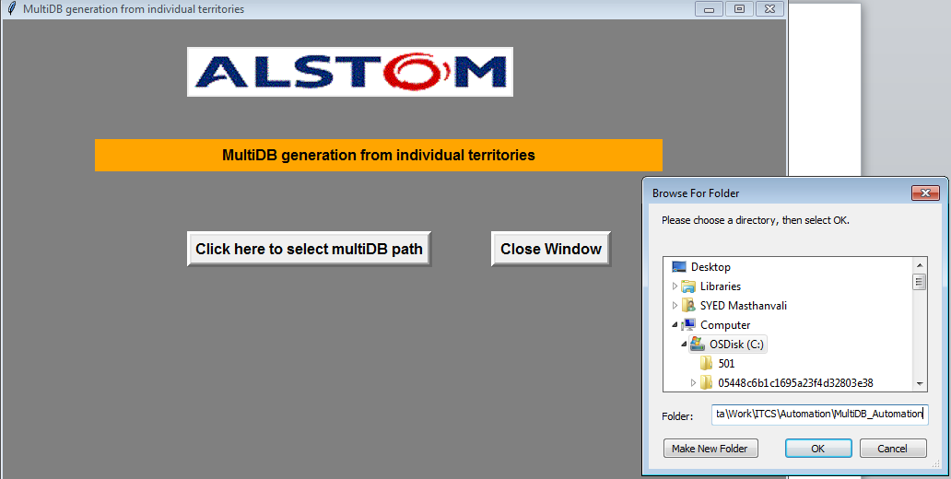

1. After selecting the path, click on button “convert to MultiDB”, then you can see the status/percentage of execution completed in status bar in GUI.
2. Finally dialog box will be popped up and that gives the info where exactly output generated with multiple territories.

For any queries contact [Masthanvali.syed@alstomgroup.com](mailto:Masthanvali.syed@alstomgroup.com).